Mississippi History

We will be examining Native American tribes lived, including their homes, roles, beliefs, clothes, games, traditions, and food.

Math

Dividing Whole Numbers

**Homework:**

**Monday:** Division WS

**Tuesday:** Division WS

**Wednesday**: Division WS

**Thursday:** None

**Graded Assignments:**

**Wednesday:** Division Quiz

**Friday:** Do Now Quiz (minor)

Contact me at: emwilliams@pearlk12.com

Language Arts:

Firsthand and Secondhand Accounts

Reviewing Text Structure

**Homework:**

**Monday:** Text structure worksheet, Read AR

**Tuesday:** Text structure worksheet, Read AR

**Wednesday:** Text structure worksheet, Read AR

**Thursday:** Read AR

**Graded Assignments**

**Thursday:** Text Structure Quiz (minor)

Contact me at: rcook@pearlk12.com

Science

**In Class:** We will be covering Weather and Climate.

**Homework:** Study science notebook each night. The vocab words can be found in the science notebook. ☺ **Test: 11/05/2020**

**Dates to Know**

**October 26 – 30:** Red Ribbon Week (see back of newsletter)

**October 29:** We are asking for each student to donate $2 for fall treats.  Please have your child turn the money in by this date.

**October 30:** Students will enjoy fall treats and may wear appropriate costumes (nothing scary or gory) to school this day.

**November 5:** Weather and Climate test

**November 6:** Weather Instrument Project Due

**2nd 9 Weeks Incentive Goals**

The student must meet 3 out of 4 goals to qualify for the incentive.

1. **Discipline** - No Bus Discipline or ODRs
2. **Tardies** – No more than 2 tardies during the 2nd 9 weeks
3. **iReady Reading** – Have an 80% pass rate for iReady ELA lessons
4. **iReady Math** – Have an 80% pass rate for iReady Math lessons

Reminders

* Please check your child’s planner each night.
* Please have your child wear tennis shoes on PE day.
* Send a water bottle and snack with your child each day.
* Please see **back of newsletter** for other important announcements.

**School Meals**

We are extremely pleased to share that **ALL** students enrolled in Pearl Public School District are able to receive **FREE** school meals. This is made possible due to the USDA extending free meal waivers for all students through December 31, 2020, or until funding is exhausted. Beginning Monday, September 14, 2020, any student enrolled in PPSD may receive both breakfast and lunch at no cost. Parents are still encouraged to complete a meal application to determine their meal status once the extension of the program ends in December. The meal applications can be completed online by going to the District website at **www.pearlk12.com** and clicking on the fork & knife icon under the slideshow.

**Red Ribbon Week**

We will have dress up days each day of Red Ribbon Week.

* **Monday (10/26)** – Wear Red
* **Tuesday (10/27)** – Tie Dye Tuesday
* **Wednesday (10/28)** - Wacky Wednesday (backwards, mismatched, silly clothing)
* **Thursday (10/29)** – Team Up Thursday (favorite sport team – I always encourage college teams if possible)
* **Friday (10/30)** – COSTUMES (nothing scary or gory)!!

d

**Fall Treats**

Pearl Upper Elementary is asking for each student donate $2 for fall treats. Please have your child turn the money in by Thursday, OCTOBER 29th.

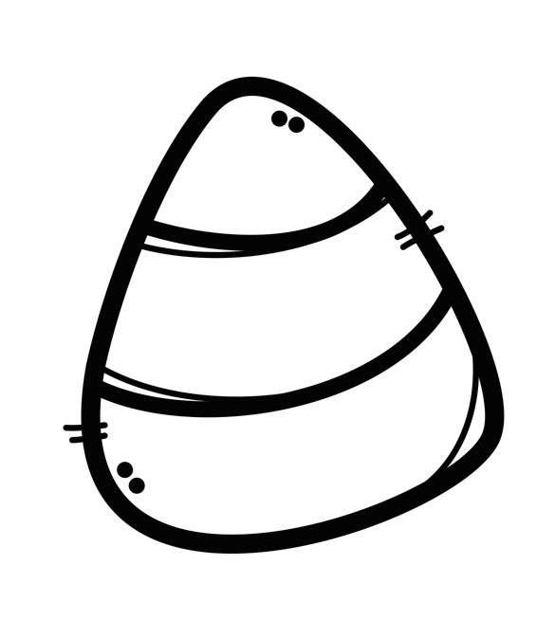

**“Socktober”**

The Pearl Upper Student Council is participating in a project called “Socktober”.  They will collect new socks of all sizes, colors, patterns and varieties to benefit the needy in our area.  The project will last the entire month of October.  Any student who brings at least 5 pairs of new socks will receive one “turn back to green” pass.  Thanks for your help with this!