**Science**

**We will continue to review all standards taught this year.**



**Language:**

**We will continue to review all standards taught this year.**

**C:\Users\nharvey\AppData\Local\Microsoft\Windows\Temporary Internet Files\Content.IE5\XB72W0V3\bi[5].jpg**

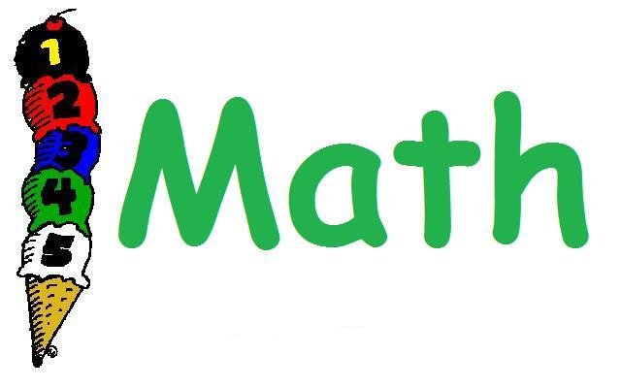

**We will continue to review all standards taught this year.**

**HOMEWORK:**

***Monday*** - ***Thursday***:

No homework will be assigned unless we

are unable to complete the classwork.

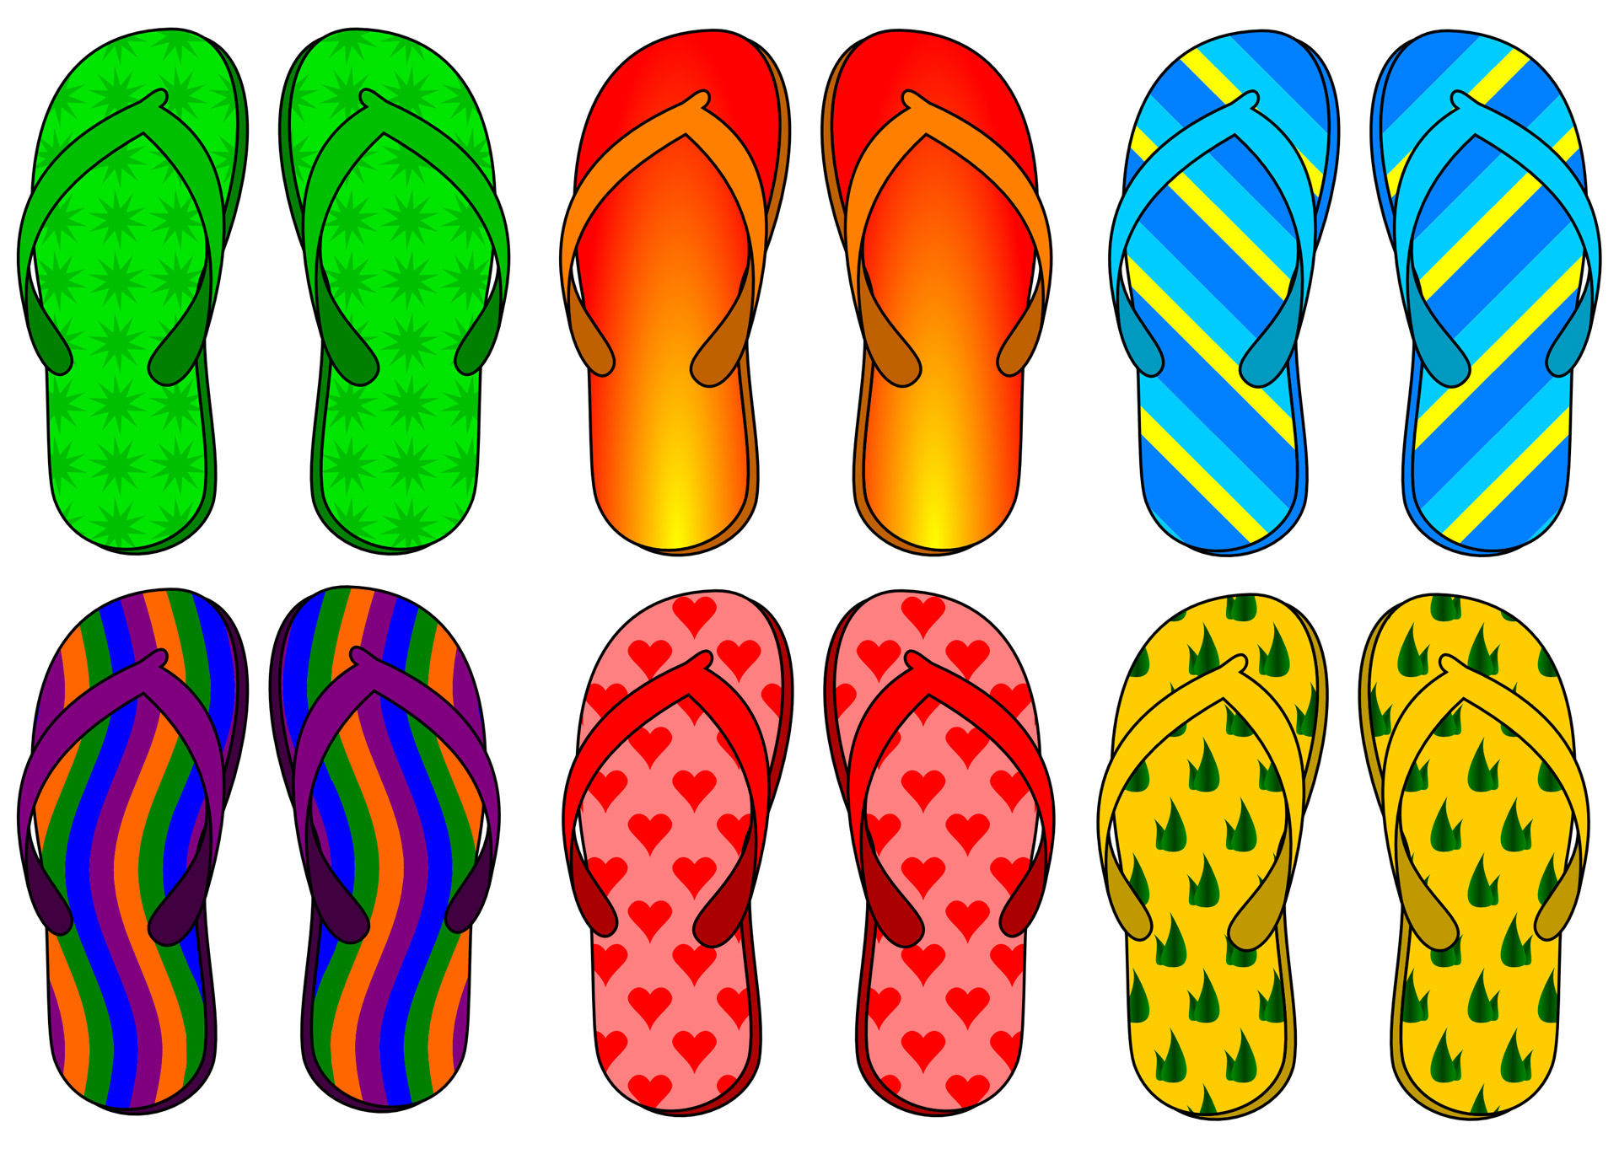

Parents,

We have truly enjoyed having your child in our classes this year. We can’t believe we are coming to the end. We also appreciate all of the teacher appreciation gifts that we received. Each and every gift meant so much to us. We hope that you all have a great summer!

Mrs. Keith & Mrs. McGriff

**News to Know…**

**May 21** – *Field Day\**

**\*** Students may wear their Survivor t-shirt with appropriate shorts or pants for Field Day.

**May 22** – *PUE Awards Day\*\**

**\*\*** Fourth grade Awards Day is from 8:30-9:30

**\*\*** Students that are receiving awards were given an invitation this past week. Only those students that are receiving an award will be allowed to go on the stage.

**\*\*** Those students should wear dress attire or uniforms, but NO BLUE JEANS will be allowed.

**\*\*** Check outs will be allowed **only after the end of the program** in homerooms.

**May 24** **–** *Last Day of School\*\*\**

**\*\*\*** This will be a 60% day.

**Reminders…**

* *Please send $1.00 for report cards as soon as possible*
* *Students are no longer allowed to charge lunch in the cafeteria*