U can play the ukulele!

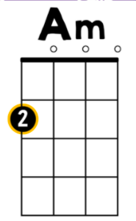
Chords we have learned so far:
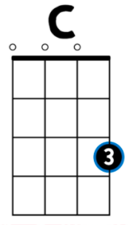
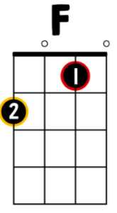
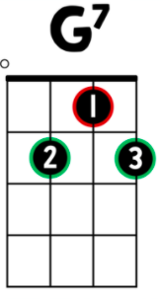

4 3 2 1
4 3 2 1
4 3 2 1
4 3 2 1

When holding the ukulele, string 1 is on the bottom.

With your parents’ permission, these websites can be helpful to find songs to play:

Ukeability.org

Littlekidsrock.org

Also, these channels on YouTube have good play-alongs*:

Ukeplayalongs – We have played “Thunder” in class is from this channel

Cynthia Lin Music

Bernadette Teaches Music

Dr. Jill Reese

Ukulaliens

*parents, please be aware that some songs found on these channel may not have lyrics suitable for students.

Have a great time!!

