How to use our Helpdesk
Type - http://helpdesk.pearl.k12.ms.us:8080 in the address bar of your browser.
Don’t forget to type http:// otherwise it won’t recognize the URL.
Type your username and password.
Using the drop down menu – Log on to - select PPSD.
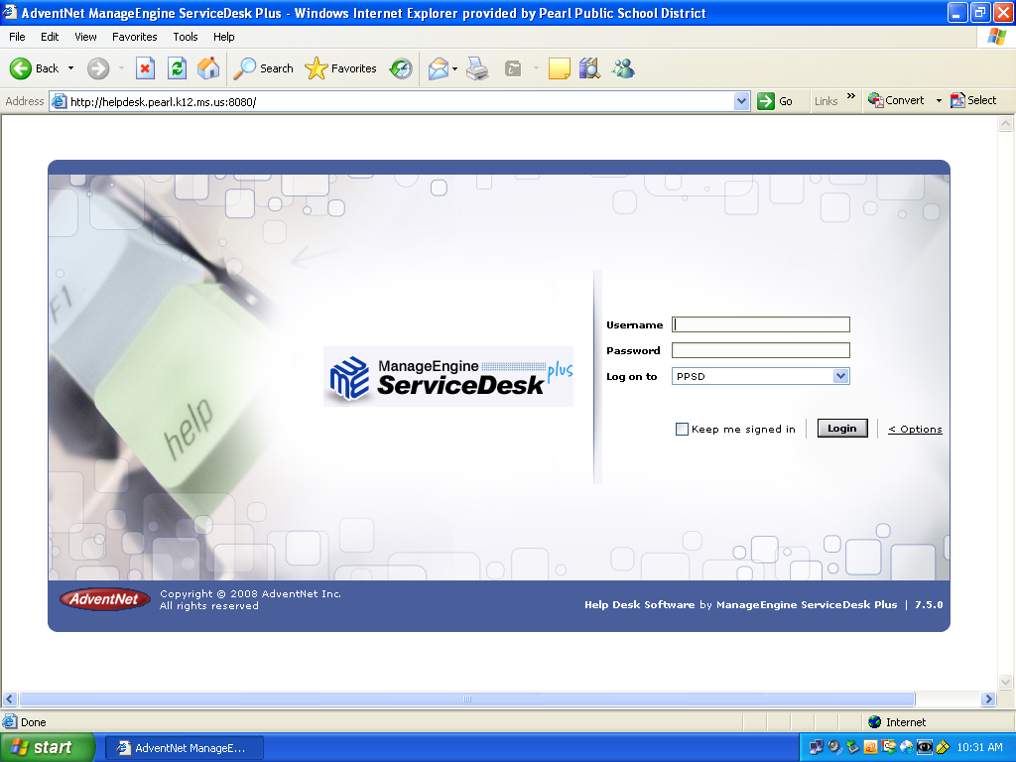

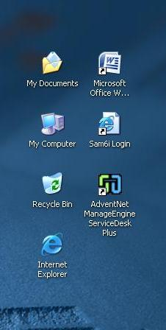

If you move your cursor to an open space in the center of the webpage and right click, you can select create shortcut, and you will be able to access the helpdesk through your desktop.

Pay close attention to these guidelines.
The system will automatically delete some requests.
If you are in doubt about whether or not you submitted the request properly. Check your request. Don’t just automatically resubmit. The system could delete both request.

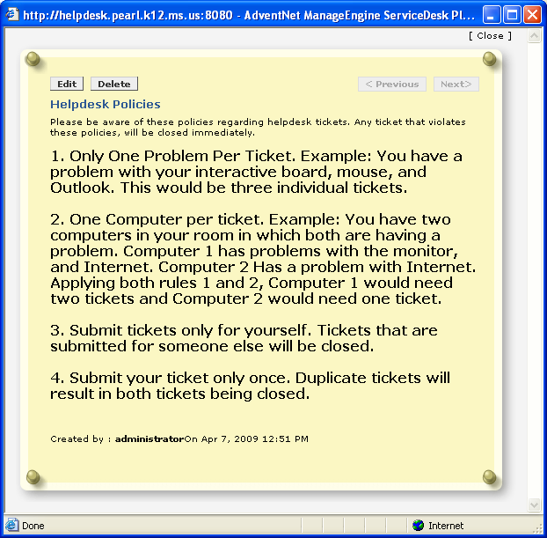
Once you’ve logged in to the system, select New Incident from the dropdown menu.
Be sure to fill in all of the appropriate items. Those with an * are required.
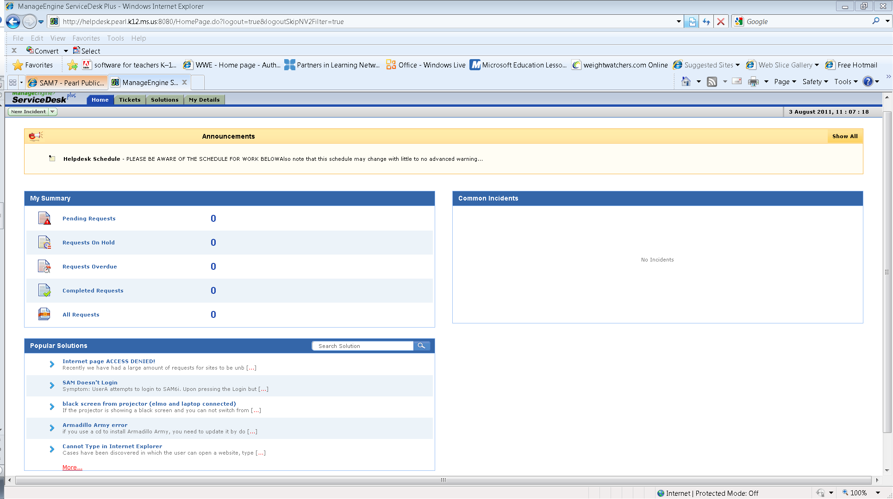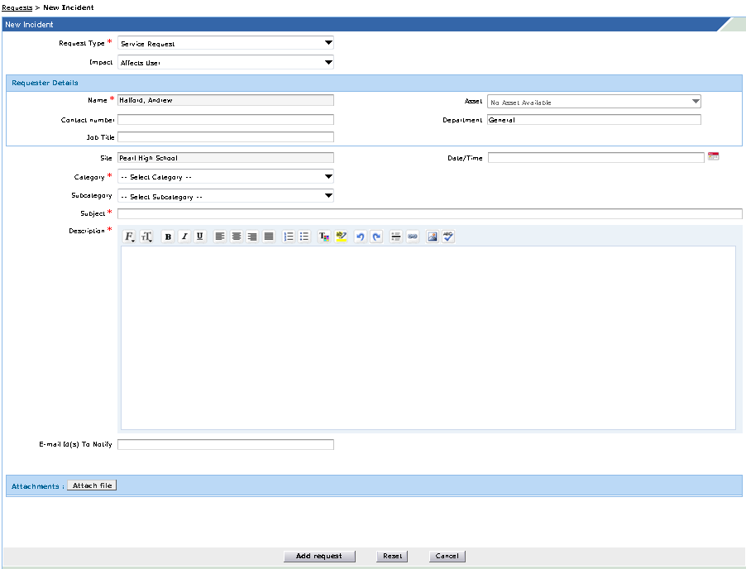
Be as descriptive as you can, it would really be appreciated!

Selecting the correct category, could mean you get the correct person.
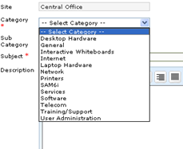
After completing the New Request, scroll to the bottom of the screen and click on Add Request.
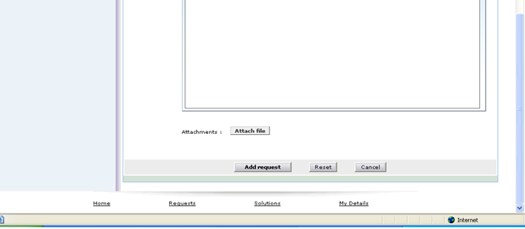
Once you have completed your request, it will be “picked up” by someone. You will receive email updates on the request to keep you informed. You may check on the request at any time.

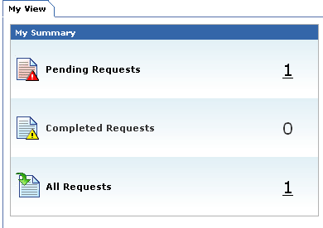
You can click on Pending Requests or All Request.

Once you click on the request, you can then select the request that you would like to view.
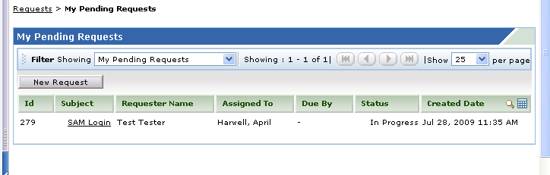
You can also view the status of each request at any time.

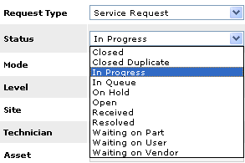

In progress might mean that a computer has been removed for repairs, or it could mean that a technician is actually on site making the repair.

You can click on and expand all entries for each request.

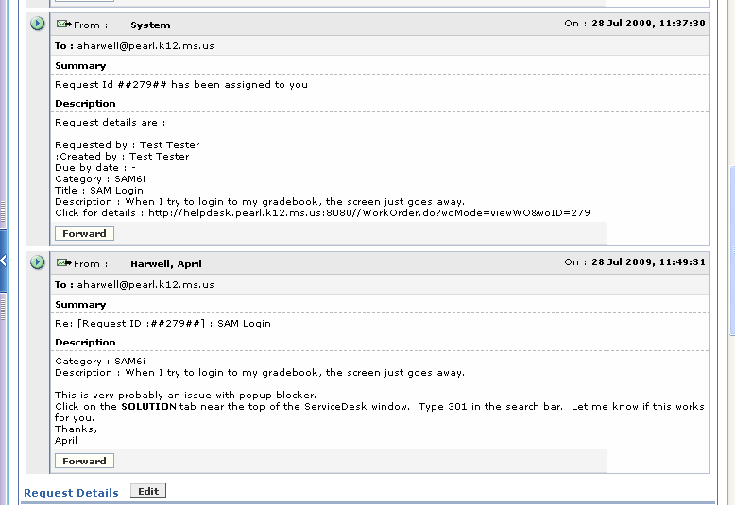
You will receive responses all throughout the process.

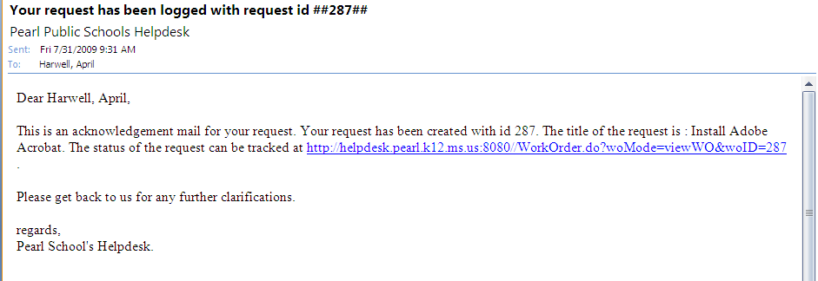

Initially, you will receive an email like the one above.

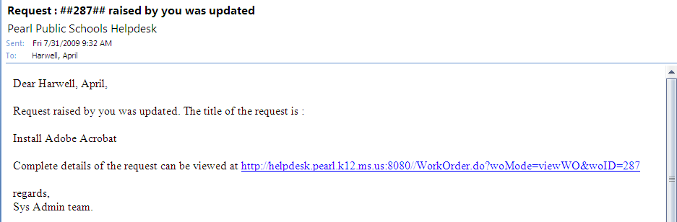

Each time an action is taken, you will receive an email similar to this one. You can click on the link to see the details.

When the technician feels that your request has been resolved, you will receive an email like the one below.
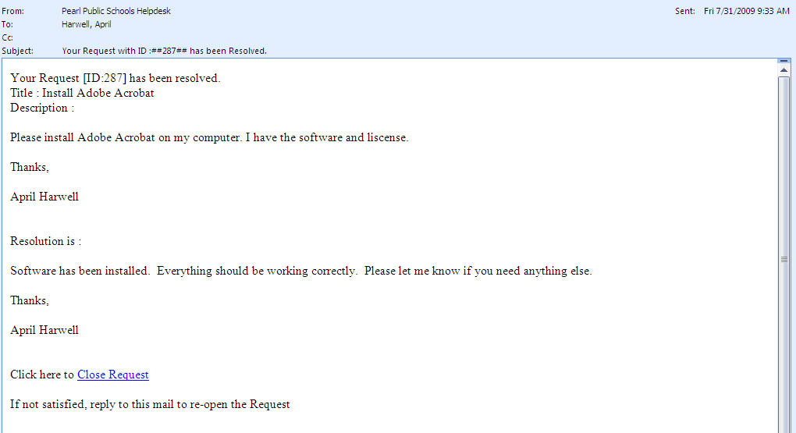
At this time, you have to decide if you are satisfied and want to close the request, or if you would like to ask them for additional assistance in the matter.
In order to keep the request open, just reply to the email and let the technician know what has not been resolved.

